
Kent Surrey and Sussex Neonatal Operational Delivery Network

Principles of Practice

Minimising Inconsistent Drug Delivery via Continuous Intravenous Infusion

Author(s) | Christian Chadwick  Pharmacy Lead - KSS Neonatal ODN
Presented for approval (to/on) | KSS Neonatal Pharmacy Group / February 2025  KSS Neonatal Clinical Governance /
Version  Date of last review | 1.0  New document
Review date (Max 3 years) | January 2028
Distribution | Neonatal Units with KSS Neonatal ODN
Implications of race, equality & other diversity duties for this document | None

Introduction
In December 2024 the British Association of Perinatal Medicine (BAPM), Neonatal Nurses Association (NNA) and Neonatal and Paediatric Pharmacy Group (NPPG) released a joint statement “Minimising Inconsistent Drug Delivery via Continuous Intravenous Infusion in Neonates”.
The full position statement can be accessed via this link:
Neonatal infusion position statement. – NPPG
In summary:
There is evidence that drug delivery via continuous intravenous infusion can be inconsistent when:
- administered at low flow rates (≤0.5mL/hr)
- there is a change in syringe pump height relative to the patient’s position
These effects, which are likely to be clinically significant with several short half-life medicines used in neonatal practice, are more pronounced when drug infusions are prepared in 50mL syringes rather than 20mL or 30mL syringes.
Refer to the position statement for further background information and supporting literature.
Principles of Practice / Recommendations
- The following medicines, when used in neonatal practice and administered by continuous intravenous infusion, should be administered from 20mL or 30mL syringes:

    - Adrenaline
    - Dobutamine
    - Dopamine
    - Isoprenaline
    - Noradrenaline
    - Argipressin (Vasopressin)

- Be aware that for short half-life drugs (listed above), changing the height of the syringe relative to the position of the baby can cause a sudden change in drug delivery.

  - If the syringe height relative to the baby increases, there is a temporary increase in drug delivery
  - If the syringe height relative to the baby decreases, there is a temporary decrease or cessation in drug delivery

- Where possible the height of the syringe pump should be adjusted in line with the patient if either needs to be moved. See appendix 1 for further guidance.

Appendices
Appendix 1: Effect of moving the baby or the syringe – infographics

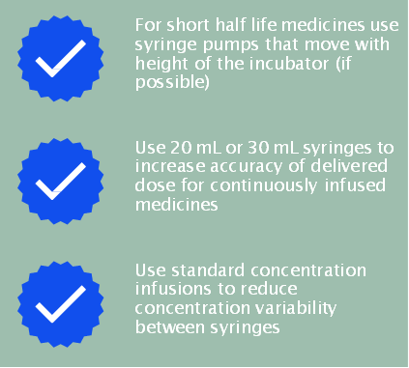

References
Position statement: Minimising Inconsistent Drug Delivery via Continuous Intravenous Infusion in Neonates. Version 1. NPPG executive November 2024. Available online at: Neonatal-Infusion-Position-Statement-V1.pdf

Scope of Guideline Framework

The guideline applies to all Neonatal Units covered by Kent Surrey and Sussex Neonatal ODN. This includes the following hospitals:

Kent, Surrey and Sussex
Medway Hospital NHS Foundation Trust | Medway Maritime Hospital, Gillingham
East Kent Hospitals University NHS Foundation Trust | William Harvey Hospital, Ashford Queen Elizabeth the Queen Mother, Margate
Ashford and St Peter’s NHS Foundation Trust | St Peter’s Hospital, Chertsey
University Hospitals Sussex NHS Foundation Trust | Royal Sussex County Hospital, Brighton Princess Royal Hospital, Haywards Heath  Worthing Hospital
Frimley Health NHS Foundation Trust | Frimley Park Hospital
Surrey and Sussex Healthcare NHS Trust | East Surrey Hospital, Redhill
Maidstone and Tunbridge Wells NHS Trust | Tunbridge Wells Hospital, Pembury
Dartford and Gravesham NHS Trust | Darent Valley Hospital, Dartford
East Sussex Healthcare NHS Trust | Conquest Hospital, Hastings
Royal Surrey NHS Foundation Trust | Royal Surrey County Hospital,

Version Control:
Version | Date | Details | Author(s) | Comments
Review date:

